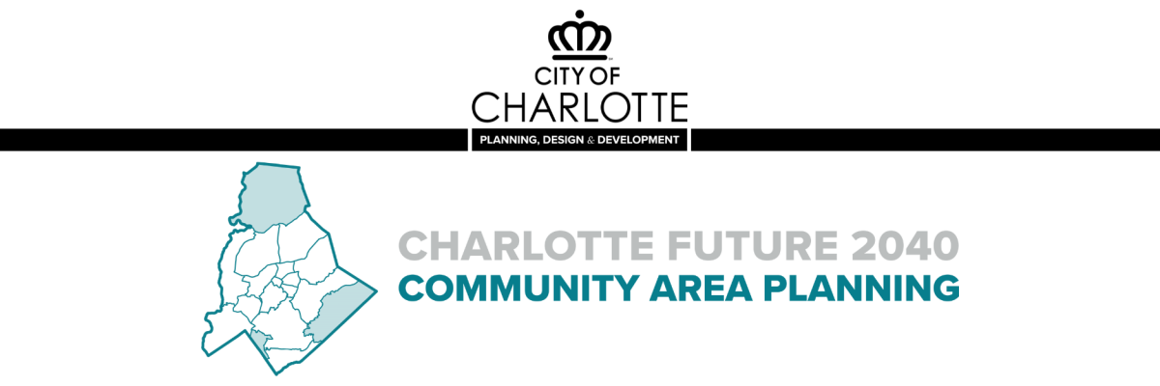

Dear Charlotte Future 2040 Partners:
The Charlotte Future 2040 Community Area Planning process has begun!
Community Area Planning builds upon the vision and goals in the Charlotte Future 2040 Comprehensive Plan and provides more detailed guidance regarding development, infrastructure, transportation, and other quality of life factors.
The City will work collaboratively with stakeholders to develop draft plans for 14 planning areas over the next two years. The planning process includes 5 phases:
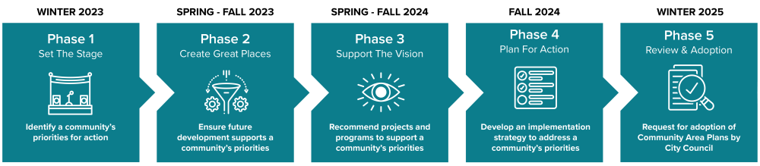

Ways to Engage
- Read your Community Report - The first step in developing the Community Area Plans is to understand:
- Who lives, works, and plays in the community today?
- What growth is expected for the community by 2040?
- What are the community’s greatest needs to ensure the expected growth benefits everyone?
View your Community Report

- Attend a Workshop – To learn about the Community Area Planning process and to share your input regarding future development and growth in your area.
View the full workshop schedule

- Attend Monthly Library Office Hours – Join us for monthly office hours on the first & second Wednesday of each month from 10:00 a.m. – 2:00 p.m at a library near you. Staff will be there to answer questions and share information throughout the Community Area Planning process.
View the full list of library locations

- Check out the Community Area Planning Workbook - This resource is the first opportunity for Charlotte neighborhoods to get involved and shape the outcomes of the Community Area Planning process. The Workbook includes exercises to help facilitate conversations among one or several neighborhoods and identify valuable resources in their community. The input collected will help confirm issues and opportunities in each community, refine citywide mapping guidance, and identify needed projects and programs. Neighborhoods may complete one, two, or all of the workbook activities.
Printable Version
Digital Version

- Explore the Community Area Planning Ambassador Toolkit - Help spread the word with the Community Area Planning Ambassador Toolkit! Use the provided templates for print, E-mail, social media, and other tools to share information on the Community Area Planning Process with the click of a button!
View the Community Area Planning Ambassador Toolkit

Stay Involved
Visit cltfuture2040.com
We will continue utilize the project website to share information throughout the process, please visit cltfuture2040.com

Follow @cltplanning
Follow us on Facebook, Instagram and YouTube to keep up with the latest news, updates, and upcoming events.

Thank you,
The Charlotte Future 2040 Team

